Science Knowledge Survey
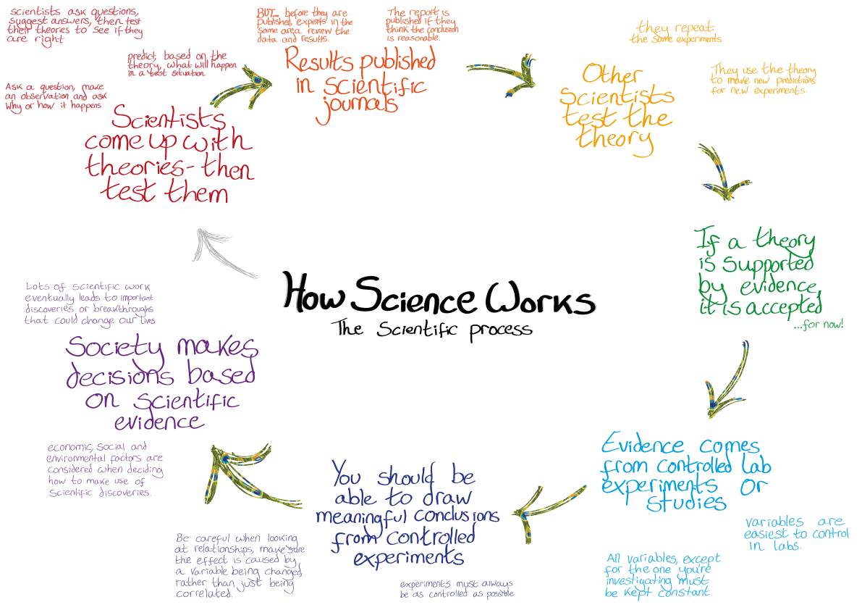
This survey is given to check your understanding about the nature of modern science and certain basic science concepts. Please agree or disagree with each item below as you think a working scientist would. Feel free to discuss this with your small learning group.
- Science is primarily the search for the truth.

- Science can solve any problem or answer any question.

- Science is primarily concerned with understanding how the natural world works.

- Science can use supernatural explanations if necessary.

- Astrology is a science.

- Science requires a lot of creative activity.

- Science typically provides only temporary answers to questions.

- A "hypothesis" is just an "educated guess" about anything.

- Scientists can believe in God or a supernatural being and still do good science.

- Science is most concerned with collecting facts.

- Most engineers and medical doctors are actually scientists.

- A scientific fact is absolute, fixed and permanent.

- Science can be done poorly.

- A scientific theory is merely a guess.

- Scientists have solved most of the major mysteries of nature.

- Science can study and explain events that happened millions of years ago.

- Knowledge of what science is, what is can and cannot do, and how it works, is important for all educated people.

- Modern scientific experiments usually involves trying something just to see what will happen, without predicting a likely result.

- Anything done scientifically is always accurate and reliable.

- Scientists have observed that nature apparently follows the same "rules" throughout the universe.

- Scientists often try to test or disprove possible explanations.

- Science can be influenced by the race, gender, nationality or religion of the scientists.

- All scientific problems must be studied with the scientific method.

- Disagreement between scientists is one of the weaknesses of science.

- Any study done carefully and based on observation is scientific.

